**CS3300 Stacked Bar Chart Project Documentation**

**Introduction:**

The program allows users to visualize CSV (Comma-Separated Values) data by generating a stacked bar chart dynamically based on the uploaded dataset. It employs HTML, JavaScript, and the Chart.js library to facilitate data parsing, visualization, and interactivity.

**Algorithm for Transforming Data into Bar Chart:**

1. **Data Acquisition and Processing:**

* User uploads a CSV file containing data.
* Upon file selection, the FileReader API reads the CSV file and extracts its content.
* The CSV data is split into rows and parsed to identify headers and values.

1. **Populating Dropdowns:**

* Headers from the CSV file are used to populate the dropdown menus for selecting the X-axis and Y-axis categories.
* JavaScript creates <option> elements in the HTML <select> tags to display the available categories for axis selection.

1. **Generating the Chart:**

* On clicking the "Generate Chart" button, the selected X-axis and Y-axis categories are determined.
* Iterating through the CSV rows, the program collects data according to the selected X-axis and Y-axis categories.
* Accumulated data is structured into datasets, assigning each category to its respective data set.

1. **Creating the Stacked Bar Chart:**

* Chart.js is utilized to render the chart on a canvas element dynamically.
* The datasets are configured to represent stacked bars, ensuring appropriate labeling and coloring.
* The chart's scales for the X-axis and Y-axis are adjusted to stack values appropriately.

1. **Downloading the Chart:**

* Upon clicking the "Download Chart" button, the current chart displayed on the canvas is converted into a PNG image.
* An anchor (<a>) element is programmatically created with the image's URL to trigger the download process.

**List of Data Structures Used:**

1. csvData (Variable):

* Purpose: Stores the uploaded CSV data.

1. myChart (Variable):

* Purpose: Holds the Chart.js instance for rendering the bar chart.

1. labels (Array):

* Purpose: Contains X-axis labels extracted from the CSV data.

1. datasets (Object):

* Purpose: Stores datasets for each Y-axis category selected. It collects data points for each category, structured for the stacked bar chart.

1. xAxisSelect, yAxisSelect (HTML Select Elements):

* Purpose: Represent dropdown menus to select X-axis and Y-axis categories respectively.

1. reader (FileReader Object):

* Purpose: Reads the uploaded CSV file content for processing.

1. optionX, optionY (HTML Option Elements):

* Purpose: Represents selectable options within the dropdown menus for X-axis and Y-axis category selection.

1. canvas (HTML Canvas Element):

* Purpose: Provides a drawing surface to render the bar chart.

1. link (HTML Anchor Element):

* Purpose: Facilitates the downloading of the chart as a PNG image.

**Conclusion:**

This paper described the functionality of the program that generates a stacked bar chart from CSV data. The algorithm outlines the step-by-step process of transforming data into a visual representation, and the data structures used were explained in terms of their roles and significance in achieving the chart generation and download functionalities.

**Input Example:**

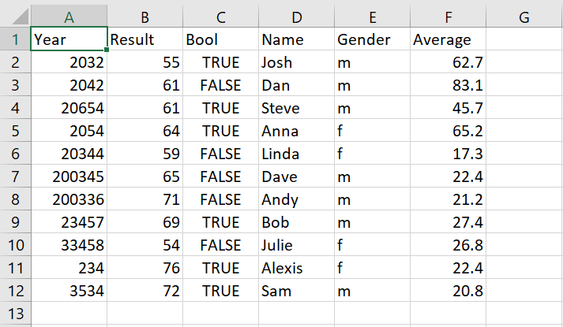

**Output Example:**

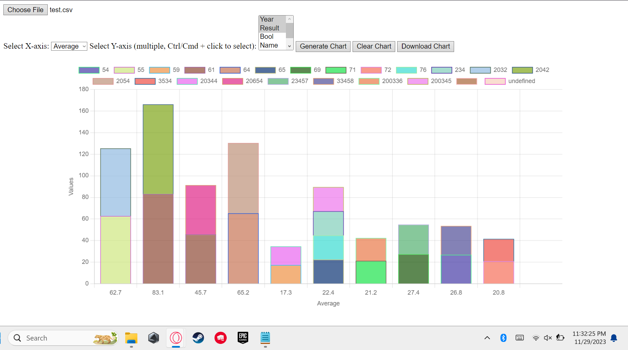

**Link to Web Application:**

<https://barchartproject.w3spaces.com/HomePageBarGraph.html>

**Link to Project File with Sample CSV:**

<https://drive.google.com/drive/folders/11ai3f3kZMP_IO5y-qM2PkzaWjfl3XW_Z?usp=drive_link>

**Work Cited**

Tripathi, Saurav. "Data Visualisation In Java." Web, Published on Sep 13, 2021,

<https://sauravmanitripathi.medium.com/covid-19-data-visualizer-in-java-466552805489>.

createwithdata.com. "Visualising CSV data with Chart.js." Web, Published on Jan 19, 2019, Available at:

<https://www.createwithdata.com/chartjs-and-csv/>.

Yi, Mike. "A Complete Guide to Stacked Bar Charts." Web, Available at:

<https://chartio.com/learn/charts/stacked-bar-chart-complete-guide/>.